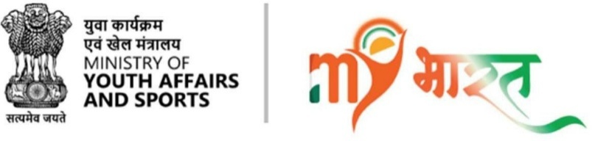

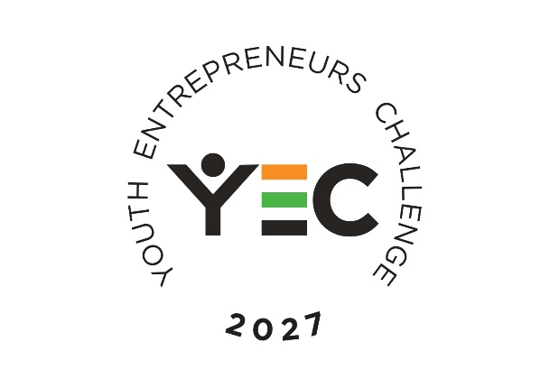
Viksit Bharat Young Leaders Dialogue (VBYLD) 2027

Youth Entrepreneurs Challenge 2027
A National Start-Up Challenge under VBYLD 2027

Participant Guidelines

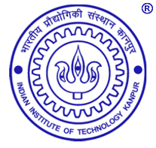
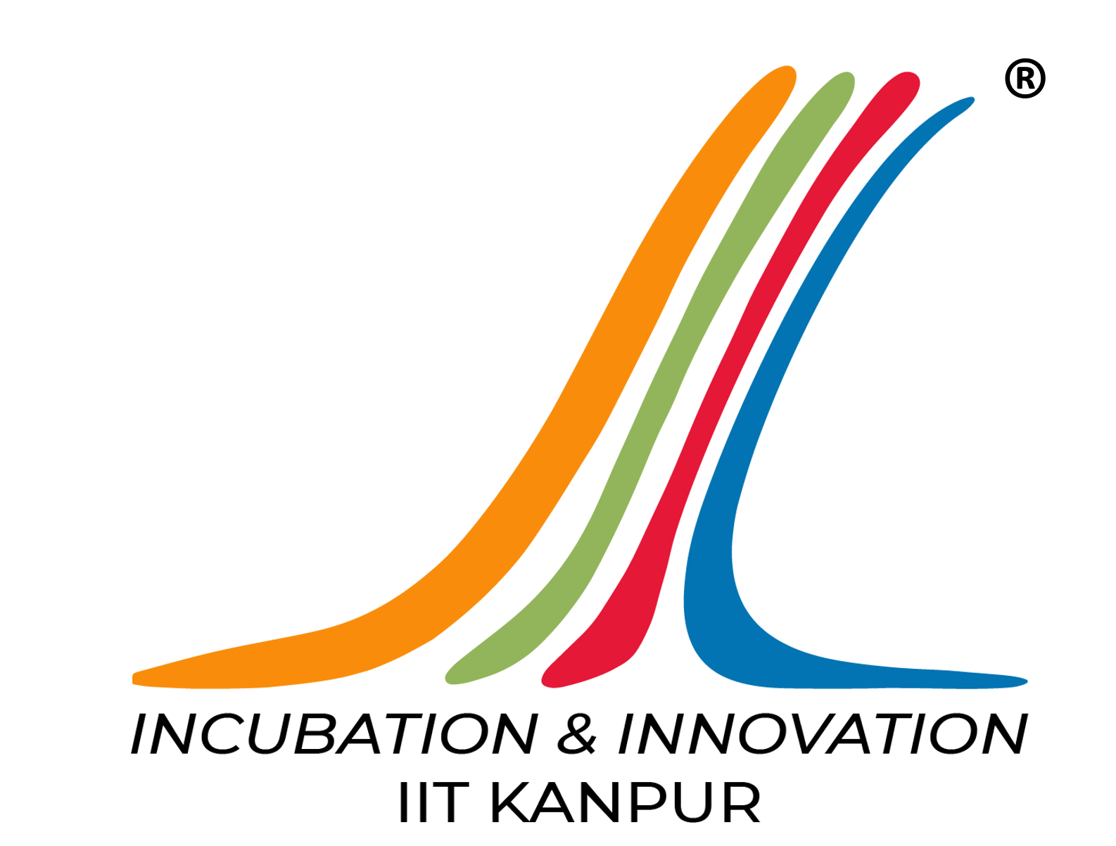

Knowledge Partner
SIIC, IIT Kanpur
Official Participant Guide
Ministry of Youth Affairs & Sports
Government of India
Foreword
India's demographic dividend presents an unprecedented opportunity to drive innovation-led growth and nation-building. The Youth Entrepreneurs Challenge (YEC) 2027, a flagship competition under the Viksit Bharat Young Leaders' Dialogue (VBYLD) 2027, provides young innovators with a national platform to transform ideas into impactful solutions for societal challenges.
The Challenge aims to identify, mentor, and recognize promising entrepreneurs whose innovations contribute to the vision of Viksit Bharat @2047. Through a structured multi-stage competition, participants will receive expert feedback, mentorship, and an opportunity to showcase their innovations before a national jury.
This Participant Guide provides the eligibility criteria, application process, competition framework, evaluation methodology, and general terms governing YEC 2027. Participants are advised to read these Guidelines carefully before submitting their applications through the MY Bharat Portal.

INDEX
Chapter | Title | Page
1 | About the Challenge | 4
2 | Eligibility, Registration & Submission | 6
3 | Competition Process | 9
4 | Evaluation Framework | 12
5 | Mentorship, National Showcase & Awards | 13
6 | Code of Conduct & General Terms | 15
7 | Frequently Asked Questions | 17
Annexure I | Challenge Themes | 22

CHAPTER 1: ABOUT THE CHALLENGE
1.1 About YEC 2027
The Youth Entrepreneurs Challenge (YEC) 2027 is a national innovation and entrepreneurship competition organized by the Ministry of Youth Affairs & Sports (MoYAS) as part of the Viksit Bharat Young Leaders' Dialogue (VBYLD) 2027. The Challenge seeks to identify, mentor, and recognize youth-led innovations that address real-world societal challenges through scalable, technology-driven, and sustainable solutions.
The competition is hosted on the MY Bharat Portal and is implemented with support from the National Knowledge Partner SIIC, IIT Kanpur, and Regional Nodal Institutes.
  - Objectives
YEC 2027 aims to:
- Encourage innovation and entrepreneurship among India's youth.
- Promote solutions addressing local, regional, and national challenges.
- Support scalable innovations with measurable social impact.
- Connect young innovators with mentors, industry experts, and policymakers.
- Recognize and showcase outstanding entrepreneurial talent pan India.
1.3 Who Can Participate?
The Challenge is open to Indian citizens aged 18–35 years under the following categories:

- Startup Founders
- Working Professionals

If you see a challenge and believe you can solve it, YEC is for you.
  - Competition Journey
The Challenge will be conducted through the following stages:
- Registration & Submission
- Regional Screening
- Regional Jury Evaluation & Pitch
- Selection of National Finalists
- Online Mentorship
- Offline Bootcamp
- National Showcase & Jury Evaluation
- Awards & Recognition

1.5 Competition at a Glance
Organizer: Department of Youth Affairs, Ministry of Youth Affairs & Sports, Government of India
Platform: MY Bharat Portal
National Knowledge Partner: IIT Kanpur
Eligibility: Indian citizens aged 18–35 years
Participation: Individual or Team (up to 3 members)
Submission: Innovation Proposal Pitch Deck, Demonstrative Video or Image and a final report
National Finale: 10 - 12 January 2027, VBYLD 2027
1.6 Important Dates
The competition schedule is provided below. Detailed timelines shall be notified on the MY Bharat Portal.
Stage | Dates
Registrations Open | 24 August 2026
Last date for Submission | 30 September 2026
Administrative Screening | 1 October– 4 October 2026
Regional Screening | 5 October – 11 October 2026
Regional Jury Evaluation & Pitch Events | 13 October – 26 October 2026
National Finalist Selection & Announcement | 27 October – 5 November 2026
Online Mentorship | 24 November – 15 December 2026
Offline National Bootcamp | 16 – 23 December 2026
Final Preparations & Travel | 24 December 2026 – 8 January 2027
National Showcase & Awards | 10 – 12 January 2027

1.7 Official Communication
All communication regarding YEC 2027 shall be made only through:
- MY Bharat Portal
- Official email communications

CHAPTER 2: ELIGIBILITY, REGISTRATION & SUBMISSION
2.1 Eligibility
The Youth Entrepreneurs Challenge (YEC) 2027 is open to Indian citizens aged 18–35 years in the following categories.
A. Startup Founders
Applicants must:
- Be a Founder or Co-founder of a Startup;
- Satisfy the eligibility criteria prescribed under the Startup India (DPIIT) framework or be registered as an MSME, wherever applicable;
B. Working Professionals
Applicants must:
- Be employed in a Government Department, Public Sector Undertaking, Private Organization, or Non-Governmental Organization (NGO);
- Submit an Employer No Objection Certificate (NOC).
2.2 Team Participation
Participants may apply individually or as a team.
Where a team is formed:
- A team may consist of up to three (3) members.
- One member shall be designated as the Team Leader.
- Every team member must independently satisfy the eligibility criteria.
- A participant may be associated with only one application.
2.3 Registration
Applications shall be submitted only through the MY Bharat Portal.
To register:
- Sign in or create an account on the MY Bharat Portal.
- Select VBYLD 2027 & Click on Youth Entrepreneurs Challenge (YEC) 2027.
- Complete the online Registration form.
- Upload the required documents and submission materials.
- Review and submit the application.
Applications may be edited at any time until the submission deadline. Once the submission window closes, no further changes shall be permitted.
2.4 Application Requirements
Every application shall include:
Mandatory Submission
- Innovation Proposal Pitch Deck
- Demonstrative Video or Image
- Final Report: A detailed report describing your proposed solution.
2.5 Submission Specifications
A. Innovation Proposal Pitch Deck
Pitch Deck: Upload a PDF presentation (Maximum file size: 20 MB) describing your proposed solution. The presentation should include the following:
Slide 1 – Title & Problem Statement: Title of the proposed solution, along with a clear description of the problem being addressed and the existing challenges.
Slide 2 – Solution Overview: Present your proposed solution, highlighting its key features, novelty/innovation, and how it addresses the identified problem.
Slides 3–5 – Technical Details & Validation: Describe the technical approach, implementation methodology, validation undertaken, test results (if available), and any supporting diagrams, flowcharts, or illustrations that help explain your solution.
Slides 6–7 – Expected Impact & Future Potential: Highlight the key objectives, expected outcomes, scalability, implementation potential, and any other information that demonstrates the overall value and impact of your solution.
B. Solution Video or Solution Image: Upload an HD-quality demonstration of your proposed solution. /Upload a high-resolution image representing your proposed solution.
C. Final Report: Upload a detailed report describing your proposed solution.
Technical Specifications:
- Pitch Deck: PDF | Maximum file size: 20 MB
- Solution Video: HD | Maximum file size: 100 MB
- Solution Image: 300 DPI | Maximum file size: 10 MB
- Final Report: PDF | Maximum file size: 20 MB
2.6 Declaration
By submitting an application, participants confirm that:
- the submission is their original work;
- the information and documents provided are true and accurate;
- the submission does not infringe the intellectual property rights of any third party
- They agree to abide by these Guidelines.
- Consent for display in exhibitions related to the competition on the MY Bharat Portal
Any false declaration, plagiarism, or misrepresentation may result in rejection or disqualification.
2.7 Important Note
Submission of an application does not guarantee selection for subsequent stages.

CHAPTER 3: COMPETITION PROCESS
The Youth Entrepreneurs Challenge (YEC) 2027 will be conducted through a multi-stage evaluation process culminating in the National Showcase during the Viksit Bharat Young Leaders' Dialogue (VBYLD) 2027.
3.1 Competition Journey
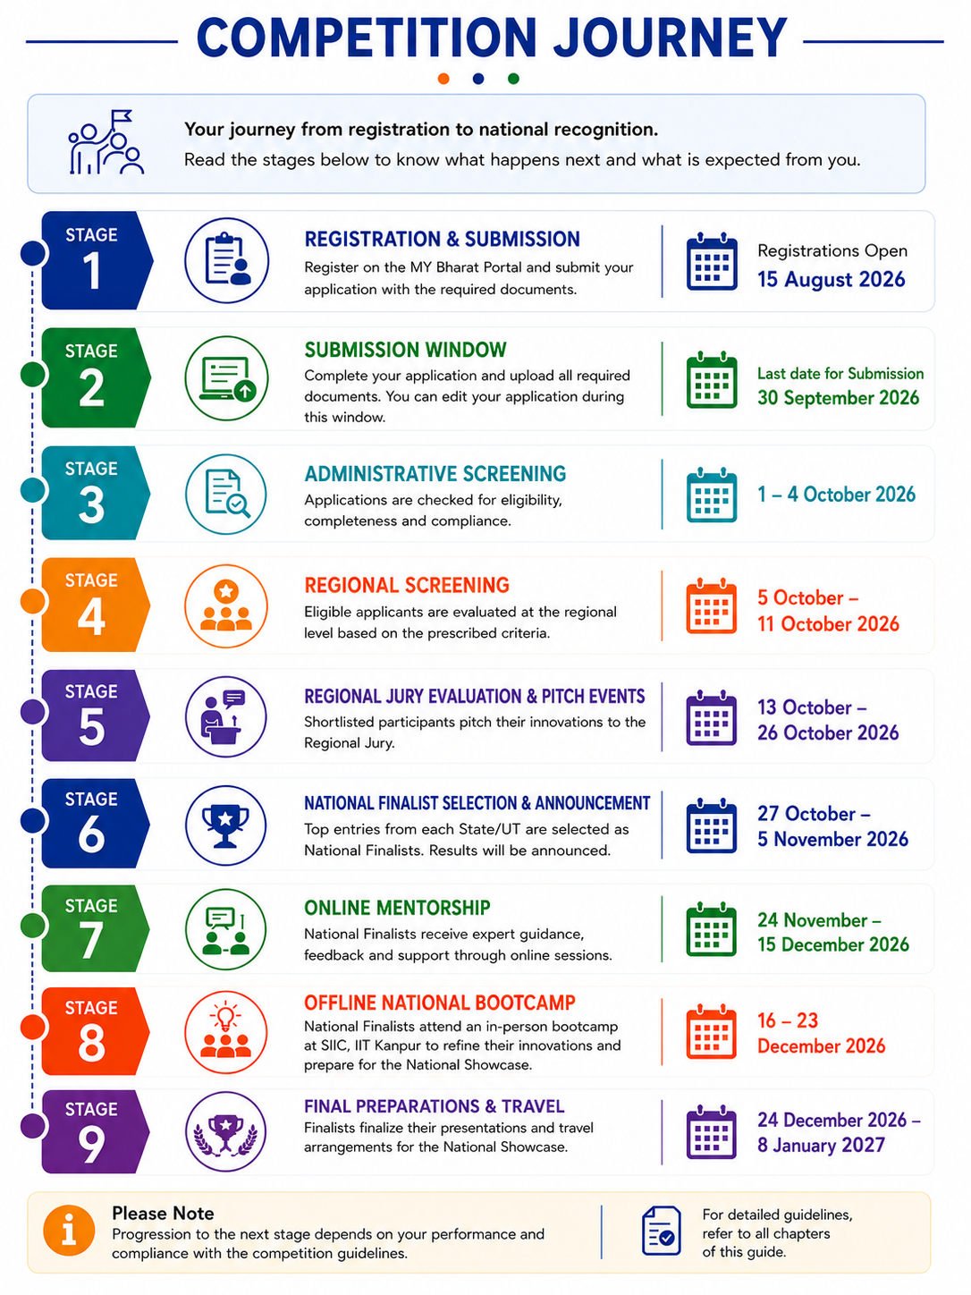
3.2 Stage 1 – Registration & Submission
Participants shall submit their applications through the MY Bharat Portal.
Only complete applications meeting the eligibility requirements shall be considered for further evaluation.
- Outcome: Eligible applications proceed to Regional Screening.
3.3 Stage 2 – Regional Screening
Applications shall undergo an initial screening to verify:
- eligibility;
- completeness of submission; and
- compliance with the prescribed guidelines.
Eligible applications shall then be evaluated using the approved screening framework.
- Outcome: Shortlisted participants will be invited to the Regional Jury Evaluation.
3.4 Stage 3 – Regional Jury Evaluation & Pitch
Shortlisted participants shall present their innovation before a Regional Jury through a pitch and interactive discussion. The Regional Jury will assess each innovation based on the evaluation framework.
- Outcome: Top entries from each State/UT shall be recommended for National-level consideration.
3.5 Stage 4 – Selection of National Finalists
Based on the Regional Jury recommendations and the National evaluation process, teams (Top Teams from each State / UT) shall be selected as National Finalists.
- Outcome: Selected teams advance to the National Mentorship Program.
3.6 Stage 5 – National Mentorship
National Finalists shall participate in a structured mentorship program comprising:
- Online mentoring sessions;
- Expert feedback and refinement; and
- Preparation for the National Showcase.
Mentorship is intended to strengthen the innovation before the final presentation.
3.7 Stage 6 – Offline Bootcamp
National Finalists shall attend an in-person bootcamp.
The bootcamp will focus on:
- innovation refinement;
- presentation readiness;
- mentoring by domain experts; and
- showcase preparation.
3.8 Stage 7 – National Showcase
National Finalists shall exhibit their innovations during VBYLD 2027 through:
- an innovation showcase;
- a jury presentation; and
- interaction with experts, policymakers, and other stakeholders.
3.9 Stage 8 – Awards & Recognition
Following the final evaluation, the MoYAS shall announce the winners and confer awards during the National Showcase.
  - Travel & Participation
The Participants shall receive travel support, in accordance with the applicable norms, as follows:
- Shortlisted teams will be invited for offline Regional Jury Evaluation and Demonstration at the designated Regional Nodal Institute; and
- National Finalists invited to attend the Offline National Bootcamp and National Showcase.
Detailed travel, accommodation (where applicable), and reimbursement instructions shall be communicated separately to the eligible participants.
3.11 Important Note
Progression to the next stage is not automatic. Advancement is based solely on performance in the preceding stage and compliance with the competition guidelines.
The decision of the Jury shall be final and binding.

CHAPTER 4: EVALUATION FRAMEWORK
4.1 Evaluation Process
All eligible applications shall be evaluated through a multi-stage process by independent experts and nominated jury members.
Evaluation at each stage shall be based on the objectives of the Challenge, the quality of the innovation, and its potential to create meaningful impact.
4.2 Evaluation Parameters
Applications may be assessed on one or more of the following parameters:
- Relevance of the problem being addressed
- Innovation and originality
- Feasibility and implementation potential
- Scalability and sustainability
- Social, economic, or environmental impact
- Quality of the proposal and presentation
4.3 Jury Interaction
During the evaluation process, participants will be required to:
- present their innovation;
- demonstrate a prototype, where available;
- respond to questions from the Jury; or
- provide additional information or supporting documents.
Failure to comply with the prescribed timeline may affect the evaluation.
4.4 Decision of the Jury
The Jury shall evaluate each application independently and objectively.
The Jury's decision regarding evaluation, shortlisting, and selection shall be final and binding.
No correspondence regarding evaluation outcomes shall ordinarily be entertained.

CHAPTER 5: MENTORSHIP, NATIONAL SHOWCASE & AWARDS
5.1 National Mentorship Programme
The National Mentorship Program is designed to support National Finalists in refining their innovations before the National Showcase.
The program includes:
- one-to-one mentoring by domain experts;
- group mentoring sessions;
- technical and business guidance;
- pitch refinement; and
- feedback on implementation and scalability.
Participation in the mentorship program is mandatory for National Finalists.
5.2 Offline National Bootcamp
National Finalists shall be invited to attend an Offline National Bootcamp prior to the National Showcase.
The Bootcamp will provide opportunities to:
- interact with mentors and industry experts;
- refine innovations based on expert feedback;
- strengthen presentations and pitches; and
- Prepare for the National Jury evaluation.
- Visit and explore IIT Kanpur
Detailed program schedules shall be communicated separately to the selected teams.
5.3 Participant Support
To facilitate participation in the National Showcase, we seek to provide the following support to eligible participants:
- Online and offline mentoring;
- Team-wise TA/DA for offline events;
- Financial support towards poster printing and prototype enhancement, wherever applicable; and
- Logistical support for participation in the National Showcase.
Detailed instructions shall be communicated directly to the shortlisted teams.

5.4 National Showcase
National Finalists shall present and exhibit their innovations during the National Showcase as part of the Viksit Bharat Young Leaders' Dialogue (VBYLD) 2027.
The Showcase will provide participants with an opportunity to:
- present before the National Jury;
- demonstrate their innovation;
- interact with policymakers, industry leaders, and experts; and
- showcase their work on a national platform.
5.5 Awards & Recognition
In accordance with the National Jury's recommendations, outstanding innovations shall be recognized during the National Showcase.
Award | Prize
First Prize | ₹1,50,000
Second Prize | ₹1,00,000
Third Prize | ₹75,000
Fourth Prize | ₹50,000
Fifth Prize | ₹30,000

In addition to the Top 5 National Awards, the following non-monetary Special Recognition Awards will be presented to acknowledge exceptional innovations demonstrating excellence in specific areas:
- Best Social Impact Innovation
- Best Women-led Innovation
- Best Rural Innovation
- Best Technology Innovation
- Jury Appreciation Award
5.6 Important Note
Participation in the National Showcase or Mentorship Program does not automatically entitle a participant to an award.
Awards shall be determined solely based on the National Jury's evaluation.

CHAPTER 6: CODE OF CONDUCT & GENERAL TERMS
6.1 Participant Responsibilities
Participants shall:
- comply with these Guidelines;
- provide complete, accurate and truthful information;
- meet all notified timelines and submission requirements; and
- conduct themselves professionally throughout the competition.
6.2 Originality of Submission
Participants shall ensure that:
- the submitted innovation is their original work;
- the submission does not infringe the intellectual property rights of any third party;
- All supporting information and documents are authentic.
Any instance of plagiarism, fabrication, or misrepresentation may result in rejection or disqualification.
6.3 Intellectual Property
The intellectual property rights in the submitted innovation shall remain with the participant(s).
By participating in YEC 2027, participants grant the Organizers a non-exclusive right to use submitted material, including photographs, videos, presentations, and innovation summaries, for evaluation, documentation, reporting, and promotional purposes, with due acknowledgment wherever appropriate.
6.4 Use of Artificial Intelligence
Participants may use Artificial Intelligence (AI) tools to assist in preparing their submissions. However, they remain solely responsible for the originality, accuracy, and authenticity of all content submitted.
6.5 Disqualification
The Organizers may reject or disqualify an application at any stage if a participant:
- is found ineligible;
- submits false or misleading information;
- violates these Guidelines;
- infringes the intellectual property rights of any third party; or
- engages in misconduct or unethical practices
- Misrepresentation or false declaration of the applicant's State/UT affiliation, including submission under a State/UT with which the applicant has no genuine and verifiable association.
6.6 Limitation of Liability
The Organizers shall not be responsible for:
- technical failures beyond their reasonable control;
- incomplete or unsuccessful submissions due to user-side issues;
- loss, damage or delay arising from circumstances beyond their control; or
- any indirect or consequential claims arising from participation in the Challenge.
6.7 Acceptance of Guidelines
Submission of an application shall constitute the participant's acceptance of these Guidelines and any subsequent instructions or notifications.
6.8 Governing Authority
The interpretation of these Guidelines and all matters relating to the conduct of the Youth Entrepreneurs Challenge (YEC) 2027 shall rest solely with the MoYAS.

CHAPTER 7: Frequently Asked Questions
General
1. What is the Youth Entrepreneurs Challenge (YEC) 2027?
The Youth Entrepreneurs Challenge (YEC) 2027 is a flagship national startup challenge under the Viksit Bharat Young Leaders' Dialogue (VBYLD) 2027. The competition aims to identify, encourage, and showcase innovative, technology-driven solutions developed by young entrepreneurs to address real-life social challenges and contribute towards the vision of Viksit Bharat 2047.
2. What is the objective of YEC 2027?
The objective of YEC is to provide a national platform for young innovators to develop scalable, technology-driven solutions to real-world social challenges while promoting innovation, entrepreneurship, and leadership among India's youth.
3. Who can participate in YEC 2027?
Startup founders and working professionals aged 18 to 35 years are eligible to participate, subject to the eligibility criteria specified in the Competition Guidelines.
Participants may apply individually or as part of a team. For team participation, all team members must individually meet the prescribed age eligibility criteria.
4. Is there any registration fee to participate?
No. Participation in the Youth Entrepreneurs Challenge (YEC) 2027 is completely free. There is no registration or application fee at any stage of the competition.
Eligibility & Teams
5. What is the maximum team size?
A team may consist of up to three members, including the Team Leader.
6. Can I submit more than one idea?
No. Each participant may submit only one idea under the Youth Entrepreneurs Challenge.
7. Can I be a member of more than one team?
No. A participant can be associated with only one team throughout the competition.
8. Can the Team Leader be changed after registration?
No. The Team Leader designated at the time of registration will remain the Team Leader throughout the competition.
9. Who is considered eligible as a Startup?
Eligible startups should:
- have founders between 18–35 years of age;
- satisfy the Startup India (DPIIT) eligibility criteria or be registered as an MSME; and
- have an industry-ready product or solution aligned with a social cause.
10. Who is considered a Working Professional?
Working professionals must:
- be between 18–35 years of age;
- be employed in a recognized Government, private, public sector or NGO organization; and
- submit an Employment Certificate and No Objection Certificate (NOC) from their employer.
Registration
11. How do I register for YEC 2027?
Participants must register through the MY Bharat Portal, select VBYLD 2027 under Events & Programs, and choose Youth Entrepreneurs Challenge (YEC) to complete registration.
12. What information is required during registration?
Participants will be required to submit:
- the selected theme;
- the problem statement or innovative idea; and
- the proposed solution through the MY Bharat Portal.
13. Can I edit my application after submission?
Yes. Applications may be edited at any time until the submission window closes. After the submission deadline, no further modifications will be permitted.
Challenge Themes
14. What themes can I submit under?
Participants may choose from the indicative themes published for the competition or propose solutions addressing other real-life social challenges aligned with the objectives of YEC and the United Nations Sustainable Development Goals (SDGs).
15. My innovation fits multiple themes. Which one should I choose?
Participants should select the theme that best represents the primary problem their innovation seeks to address.
16. Will some themes receive preference over others?
No. All themes carry equal weight. Evaluation is based primarily on the relevance of the problem statement, the quality of the proposed solution, and its potential social impact, rather than the theme selected.
17. Can I submit an idea outside the suggested themes?
Yes. The published themes are indicative. Participants are encouraged to address any real-life social challenge aligned with the objectives of YEC and the United Nations Sustainable Development Goals (SDGs).
Competition Process
18. How is the competition structured?
The competition consists of three stages:
- Registration & Nomination
- Regional Screening & Selection (three phases)
- National Mentoring & Showcasing.
19. What happens during the Regional Selection?
The Regional Selection consists of:
- preliminary screening of eligible submissions;
- shortlisting of teams per region;
- demo, pitch, and jury interaction; and
- selection of three winning teams from every State/UT.
20. How many teams qualify for the National Level?
Three teams from each State/UT are shortlisted during the Regional Competition.
IIT Kanpur then evaluates these teams using the jury score sheets and additional evaluation criteria to select one team from each State/UT, resulting in National Finalists.
Evaluation
21. How will my submission be evaluated?
Submissions are evaluated on:
- Relevance of the problem statement
- Technical robustness
- Functionality and scalability
- Originality and creativity
- Potential social and economic impact
- Quality of the presentation deck
- Effectiveness of the pitch.
22. Is originality important?
Yes. Originality is an important evaluation principle. All submissions are subject to plagiarism checks, and the jury follows standardized evaluation criteria to ensure fairness, consistency, and impartiality.
Mentorship
23. Will shortlisted teams receive mentorship?
Yes. The National Finalists will receive structured mentoring from IIT Kanpur. This includes online mentoring, followed by an in-person mentoring program at IIT Kanpur before the National Showcase.
24. What support do National Finalists receive?
Each National Finalist team will receive:
- Online mentoring by IIT Kanpur.
- Two-day offline mentoring at IIT Kanpur.
- ₹5,000 per team to support poster preparation and prototype improvement for the National Showcase.
Travel & Logistics
25. Will travel support be provided for the Regional Competition?
Yes. Teams shortlisted for the Regional Demonstration will receive an interstate Travel Allowance (TA/DA) of up to ₹10,000 per team for travel to the Regional Nodal Institute for the offline demonstration, in accordance with the competition guidelines.
26. Will National Finalists have to attend the National Showcase in person?
Yes. All 36 National Finalist teams are expected to participate in person at the National Showcase and exhibition.
National Showcase
27. What happens during the National Showcase?
All 36 National Finalist teams will:
- Set up an exhibition stall showcasing their innovation.
- Deliver a 3-minute presentation before the National Jury.
- Demonstrate the problem identified, the proposed solution and its potential impact.
- Compete for the National Awards.
Awards
28. What prizes will be awarded?
The Top 5 teams will receive cash prizes of:
- First Prize – ₹1,50,000
- Second Prize – ₹1,00,000
- Third Prize – ₹75,000
- Fourth Prize – ₹50,000
- Fifth Prize – ₹30,000
In addition to the cash awards, non-monetary Special Recognition Awards may also be conferred in select categories as announced by the organizers.
Frequently Asked
29. Can I submit an idea that is already being developed?
Yes. Existing ideas, products, or startups may participate, provided they satisfy the eligibility criteria and address a real-life social challenge. The solution should demonstrate innovation, relevance, and potential impact.
30. Where can I find updates regarding YEC 2027?
All official announcements, timelines, guidelines, and important updates will be communicated through the MY Bharat Portal and official communication mails.
Rules & Compliance
31. What happens if my application contains false, misleading, or plagiarized information?
All information and documents submitted by participants must be accurate, authentic, and complete. Any application found to contain false, misleading, or fabricated information, forged documents, or plagiarized content, or found to be in violation of the Competition Guidelines, may be rejected or disqualified at any stage of the competition, including after selection, if such discrepancies are discovered later.
The organizers reserve the right to verify the information submitted by participants and take appropriate action in accordance with the Competition Guidelines.
32. How can I contact the organizers if I need assistance?
Participants are encouraged to carefully read the Competition Guidelines and these FAQs before seeking assistance. For queries that are not addressed here, participants may contact MY Bharat Support: https://mybharat.gov.in/support

Annexure I
Challenge Themes
The Youth Entrepreneurs Challenge (YEC) 2027 invites innovative solutions that address real-world challenges and contribute towards the vision of Viksit Bharat. The themes listed below are indicative and intended to guide applicants in identifying the most appropriate category for their innovation.
Applicants are encouraged to propose innovative, scalable, and impactful solutions under the following themes or any other area aligned with national development priorities.
THEME 1: Healthcare & Public Health
- AI-Powered Rural Healthcare Access: Develop a solution to connect rural populations with quality healthcare services through telemedicine, diagnostics, and referral systems.
- Maternal and Child Health Monitoring: Create a digital platform for tracking prenatal care, immunization schedules, and child nutrition in underserved communities.
- Disease Outbreak Early Warning System: Design a data-driven system to identify and predict disease outbreaks using health, environmental, and mobility data.
- AI for Malnutrition Prediction and Intervention: Develop an AI-powered system that integrates health records, socioeconomic indicators, and nutrition data to identify children at risk of malnutrition and recommend targeted interventions.
THEME 2: Education & Skill Development
- Reducing School Dropout Rates: Develop an early-warning platform to identify students at risk of dropping out and recommend interventions.
- Personalized Learning for Government Schools: Create an AI-enabled learning platform that adapts content to individual student needs and learning levels.
- Career Guidance for Rural Youth: Design a multilingual platform providing career counseling, skill mapping, and employment opportunities.
- AI-Based Learning Recovery Framework: Design an AI system that identifies learning gaps among students and generates personalized remedial learning pathways in regional languages.
THEME 3: Agriculture & Rural Development
- Smart Advisory for Smallholder Farmers: Build a solution offering crop recommendations, weather alerts, pest management, and market intelligence.
- Farm-to-Market Supply Chain Optimization: Develop a platform that reduces post-harvest losses and improves market access for farmers.
- Water-Efficient Agriculture: Create a technology solution for monitoring irrigation and promoting efficient water use.
- Precision Agriculture for Smallholder Farmers: Develop an integrated platform using drones, IoT sensors, and AI for crop health assessment, yield prediction, and input optimization.
THEME 4: Environment & Sustainability
- Community Waste Segregation and Recycling: Design a digital ecosystem that incentivizes waste segregation, collection, and recycling at the community level.
- Urban Air Quality Monitoring: Develop a low-cost, real-time air quality monitoring and citizen alert system.
- River and Waterbody Pollution Tracking: Create a platform to monitor pollution sources and support community-led conservation efforts.
- National Water Security Intelligence Platform: Develop a predictive platform combining satellite imagery, groundwater data, rainfall patterns, and consumption trends to support water resource planning.
- Smart Energy Management for Villages: Design a community-scale energy management platform integrating solar, storage, and demand forecasting for reliable power access.
- Autonomous Waste Segregation and Circular Economy Platform: Design a smart waste management solution using computer vision and robotics to improve segregation and recycling efficiency.
- Net-Zero Villages: Develop scalable solutions to help villages achieve carbon neutrality through renewable energy, waste management, and sustainable agriculture.
THEME 5: Women & Child Empowerment
- Women’s Safety and Emergency Response: Build an integrated safety solution with location sharing, emergency alerts, and rapid response mechanisms.
- Economic Empowerment of Self-Help Groups: Develop digital tools that help women-led SHGs access markets, finance, and business opportunities.
THEME 6: Governance & Public Service Delivery
- Grievance Redressal for Citizens: Create an AI-enabled platform for efficient tracking and resolution of citizen grievances.
- Digital Inclusion for Government Schemes: Develop a multilingual assistant that helps citizens identify and access welfare schemes.
- Digital Twin for District-Level Development Planning: Create a digital twin platform for districts that simulates the impact of policies on healthcare, education, water resources, and infrastructure.
- AI for Judicial Case Prioritization: Design a solution to assist courts in categorizing cases, identifying precedents, and optimizing case management to reduce pendency.
THEME 7: Accessibility & Inclusion
- Assistive Technologies for Persons with Disabilities: Design affordable solutions that improve mobility, communication, learning, or employment opportunities.
- Accessible Public Infrastructure Mapping: Create a crowdsourced platform that maps accessibility features in public spaces and services.
- Smart Monitoring of Government Infrastructure Projects: Build a platform using drones, geospatial analytics, and AI to monitor roads, schools, hospitals, and public infrastructure projects in real time.
THEME 8: Disaster Management & Resilience
- Community-Based Disaster Preparedness: Develop an early warning and response system for floods, heatwaves, cyclones, and other disasters.
- Climate Resilience for Vulnerable Communities: Design data-driven tools that help communities assess climate risks and plan adaptation measures.
- Climate Risk Prediction for Rural Communities: Create a climate-risk intelligence system that forecasts localized impacts of floods, droughts, heatwaves, and crop failures.
- Smart Urban Flood Management: Develop a real-time flood-forecasting and drainage-management system that integrates IoT sensors, GIS, and weather intelligence.
THEME 9: AI-based disaster mitigation solution (To assist in crowd management during rallies and large-scale gatherings, preventing crowd crush and stampede.)
Note: All challenge themes carry equal weightage. The selected theme is intended solely for categorization and evaluation by the appropriate domain experts and shall not influence the overall assessment of the application.

